WEEK 2
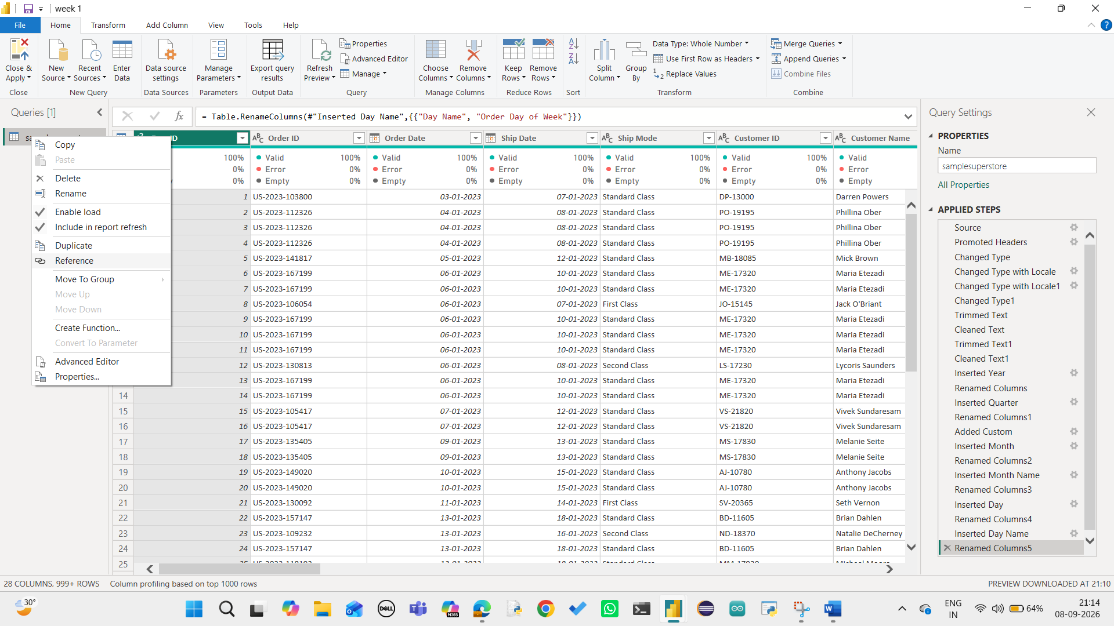
The Superstore Sales dataset was loaded into Power BI using Power Query. The samplesuperstore table contains the original sales transaction data, which is used as the main fact table for the dashboard.

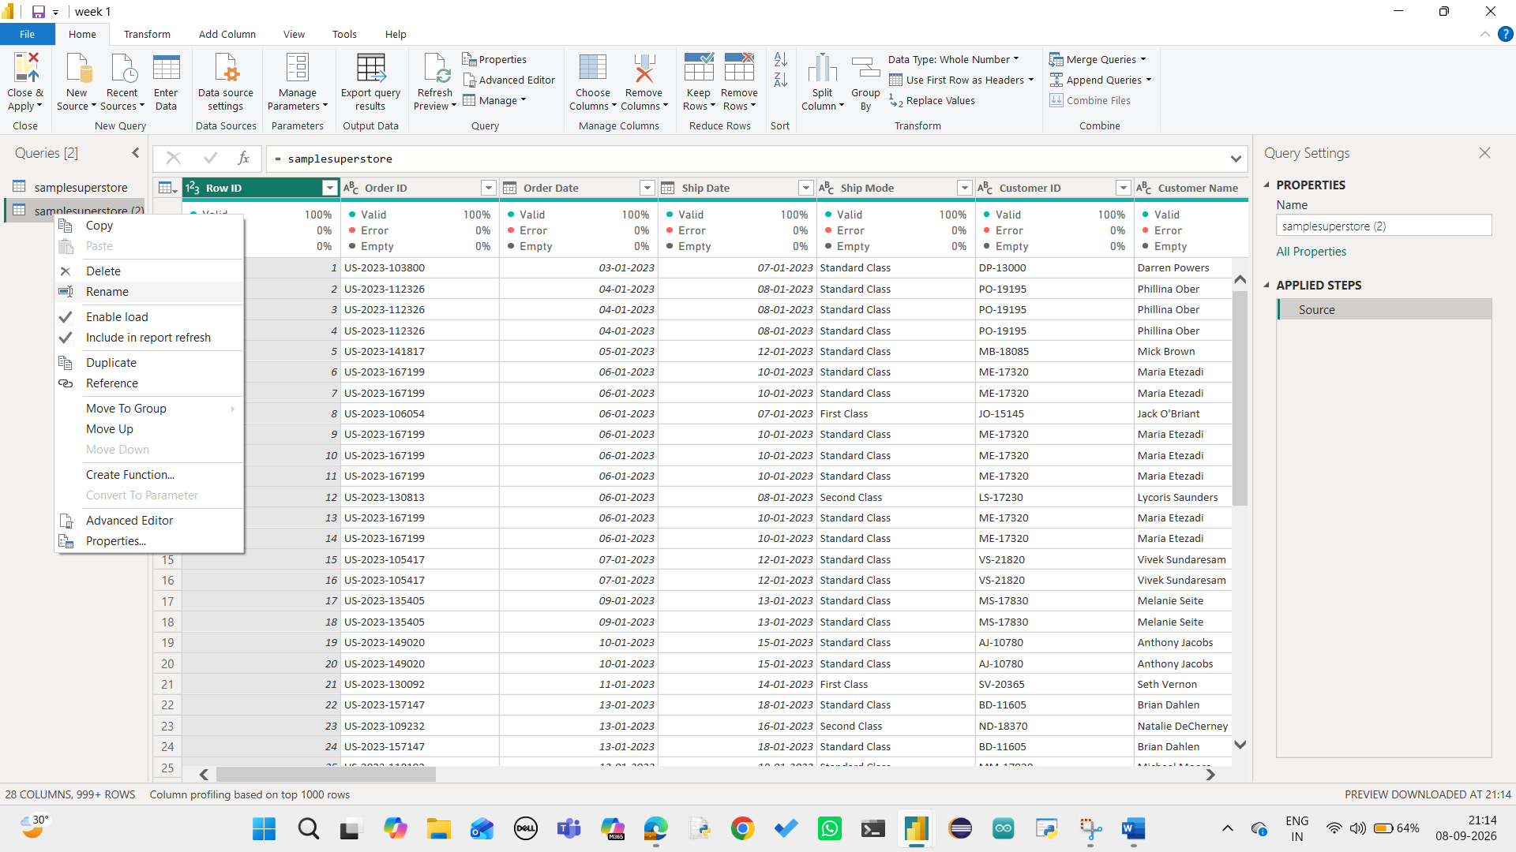
A reference of the samplesuperstore table was created in Power Query to prepare separate dimension tables. This helps organize the dataset into a structured data model.

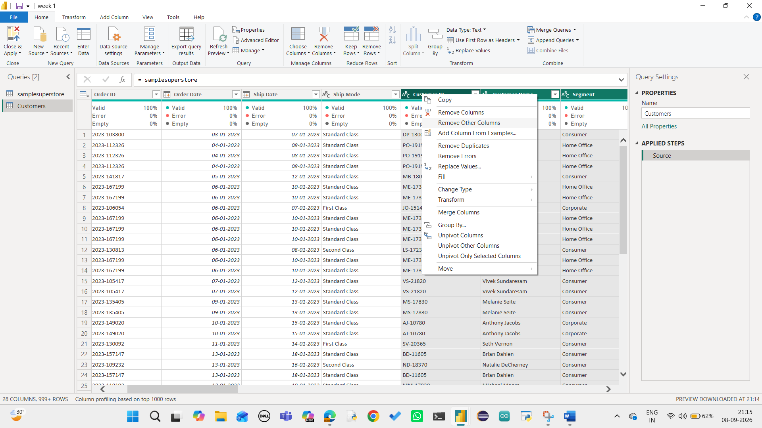
The Customers table was created from the Superstore dataset by selecting relevant customer-related fields. The table contains customer information such as Customer ID, Customer Name, Segment, City, Country/Region, Postal Code and Region.

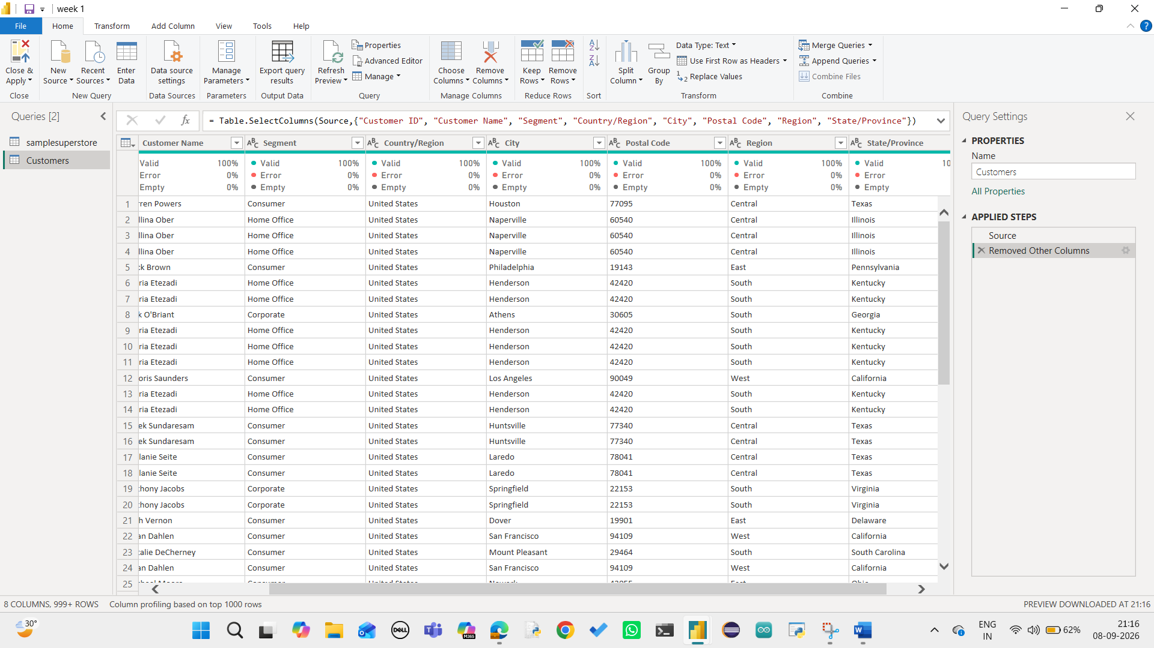
Unnecessary columns were removed from the referenced table, keeping only the required customer attributes. This creates a cleaner dimension table for customer-level analysis.
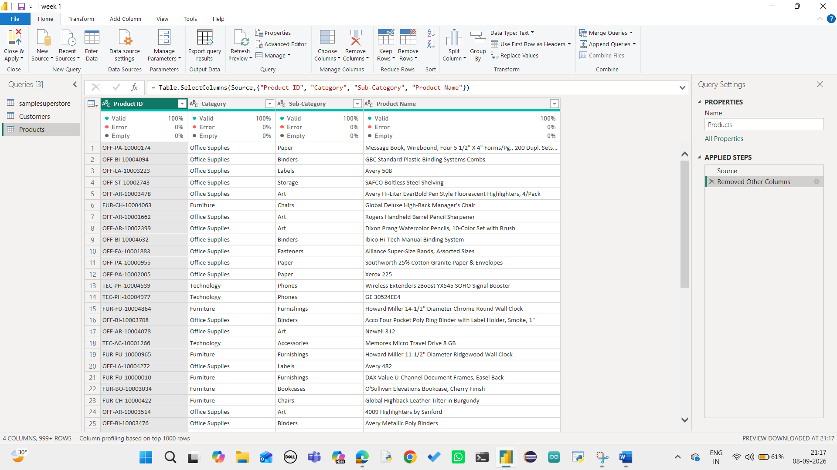
A Products table was created from the Superstore dataset using relevant product attributes. The table contains Product ID, Category, Sub-Category and Product Name

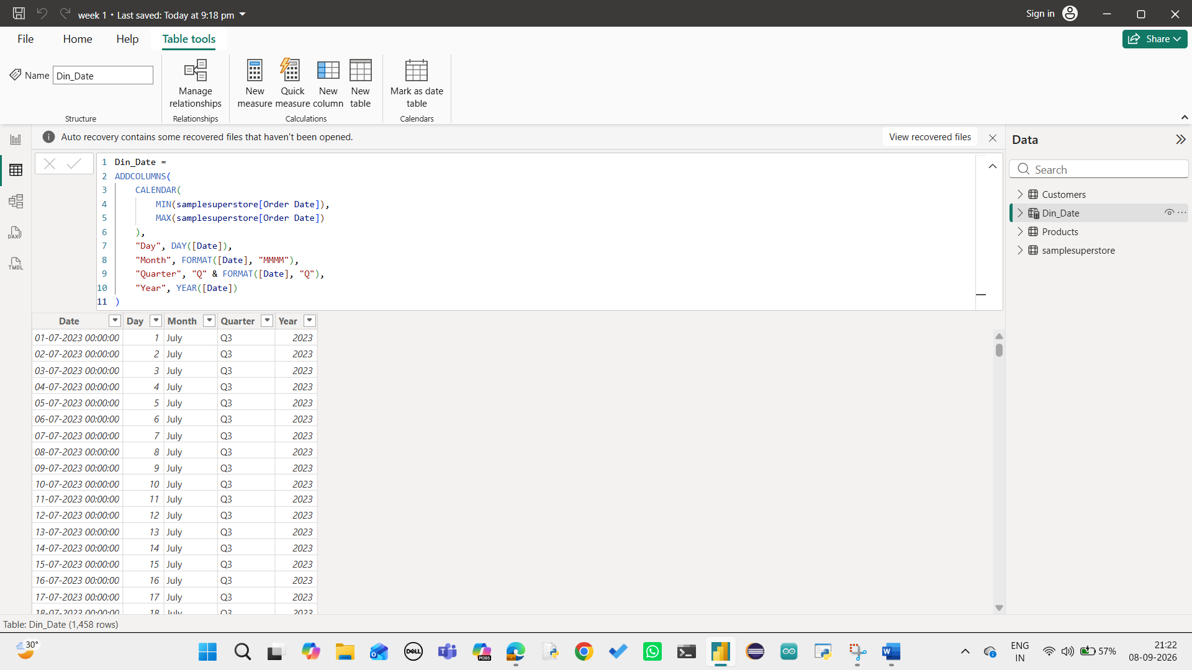
A separate Date dimension was created using DAX. The table generates dates between the minimum and maximum Order Date and includes Day, Month, Quarter and Year columns for time-based analysis.
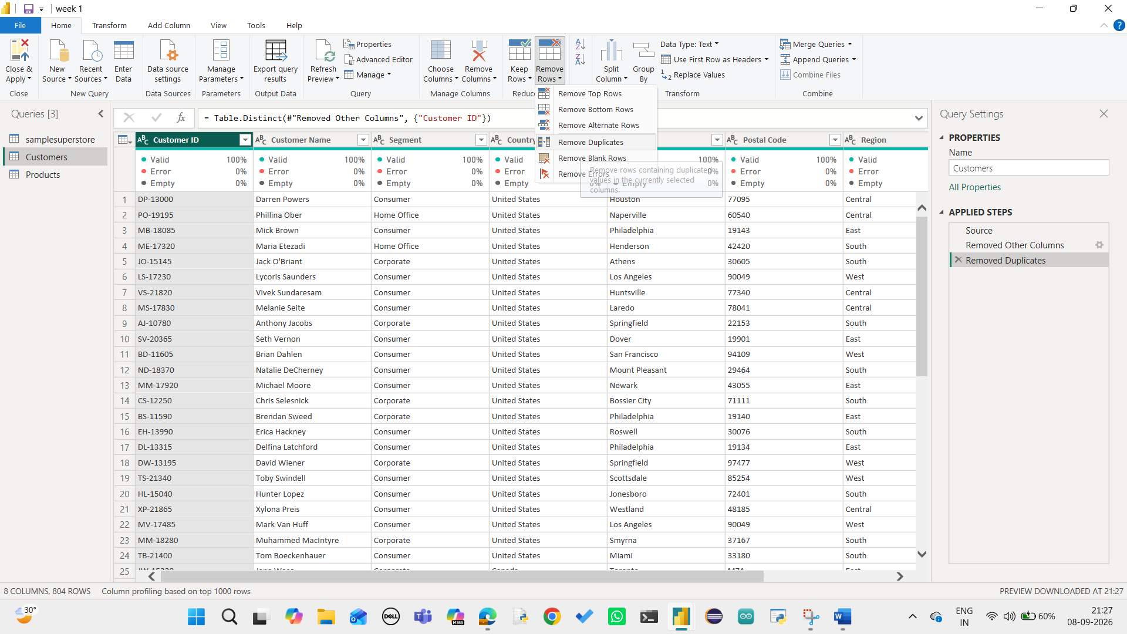
Duplicate Customer IDs were removed from the Customers table to ensure that each customer appears only once. This allows the Customer ID to function as a unique key in the data model.

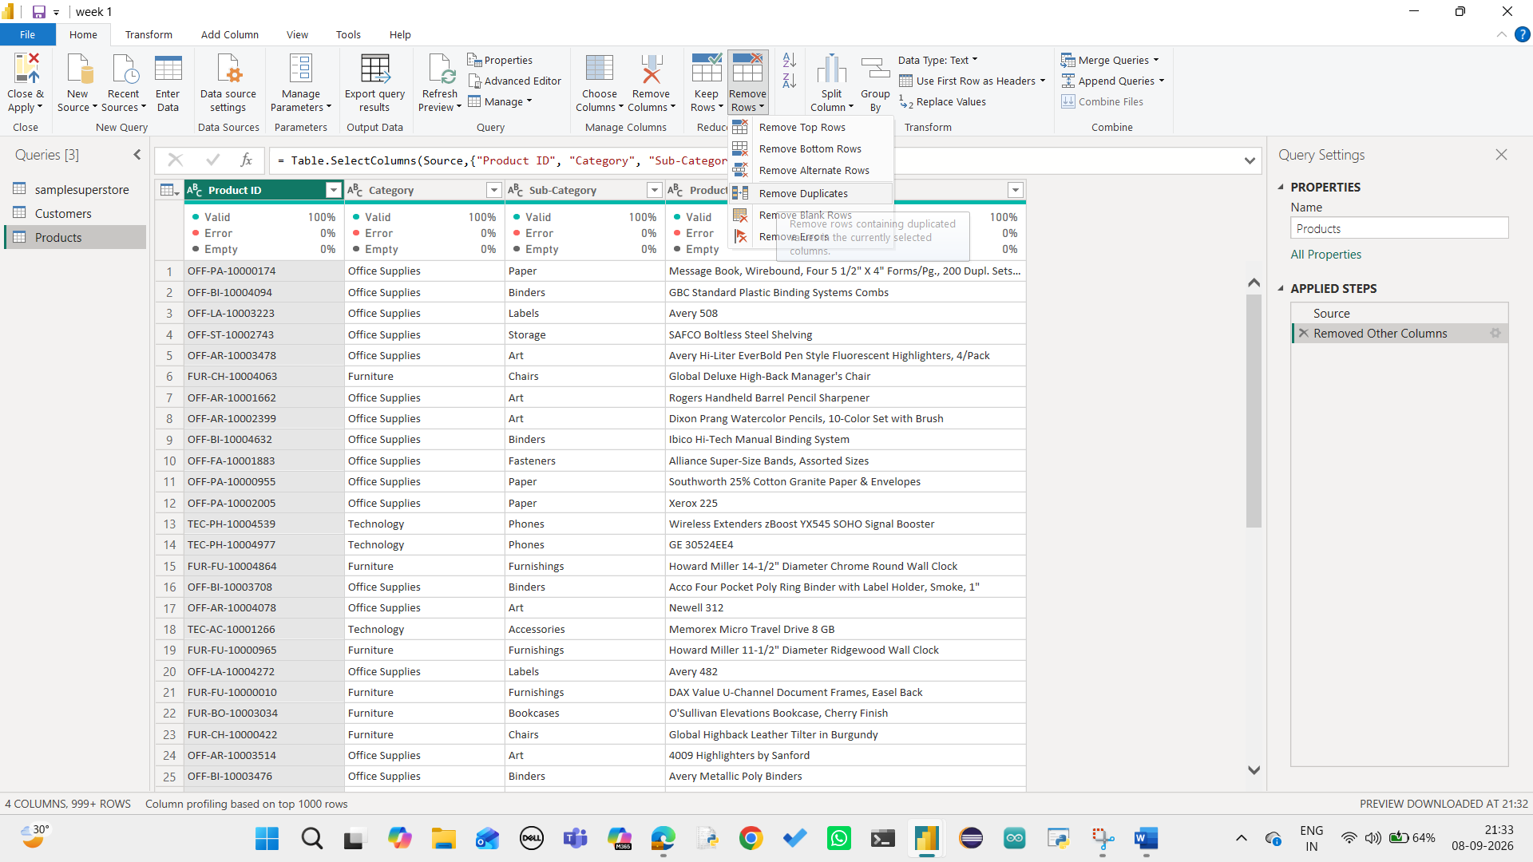
Duplicate Product IDs were removed from the Products table. This ensures that each product is uniquely represented and can be correctly related to the sales fact table.
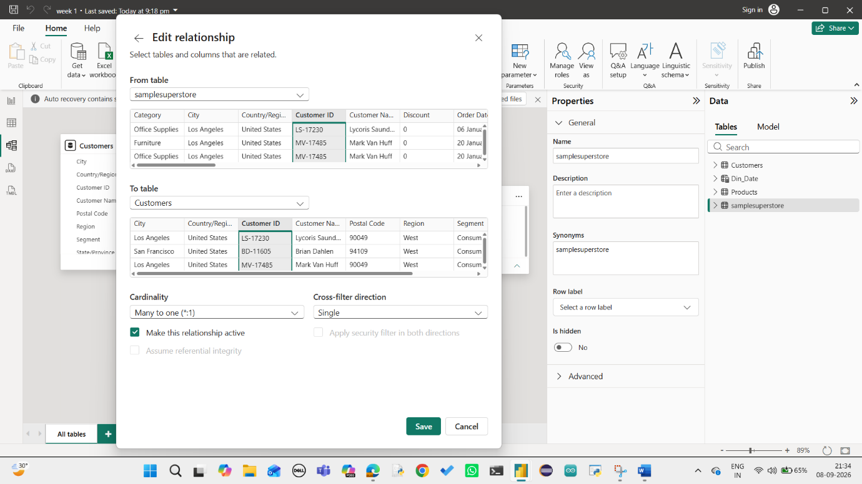
A relationship was created between the Customers table and the samplesuperstore fact table using Customer ID. The relationship connects customer information with the corresponding sales transactions.

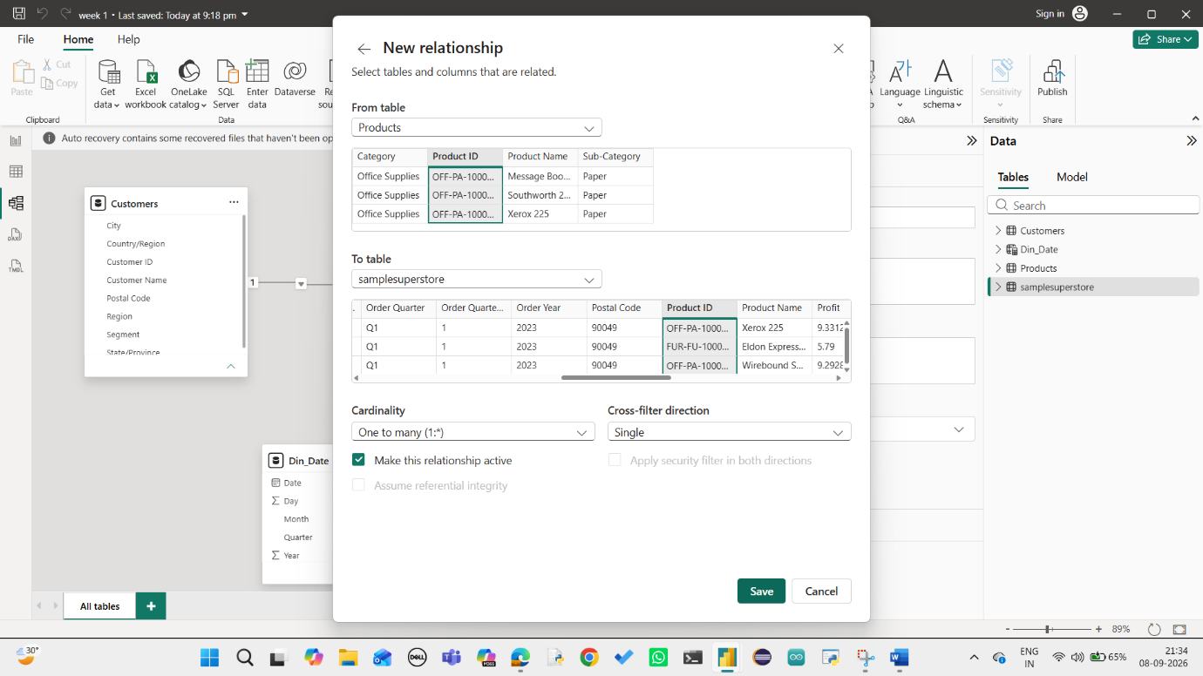
A relationship was created between the Products table and the samplesuperstore table using Product ID. This allows sales data to be analyzed according to product categories and sub-categories.
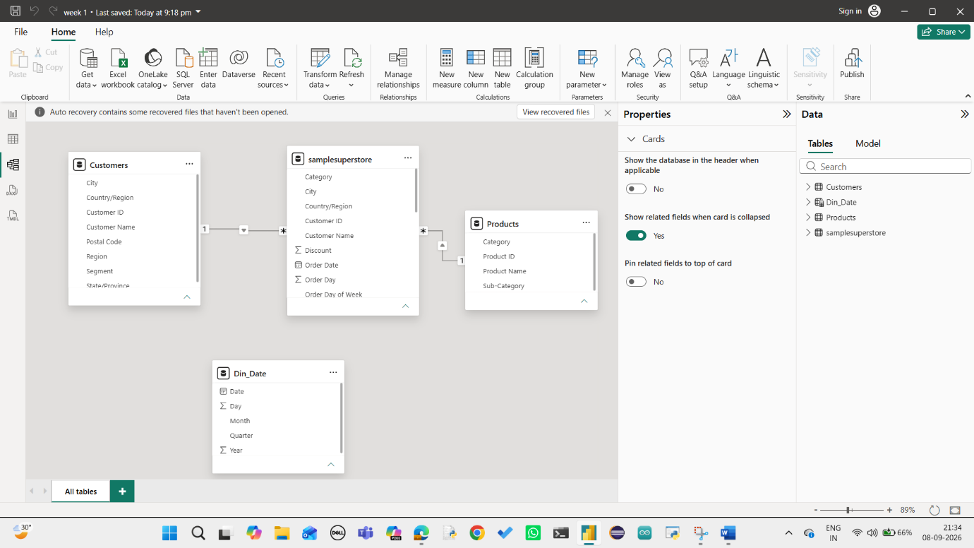
The data model follows a Star Schema structure. The samplesuperstore table acts as the central fact table, while Customers, Products and Dim_Date act as dimension tables connected through relationships.

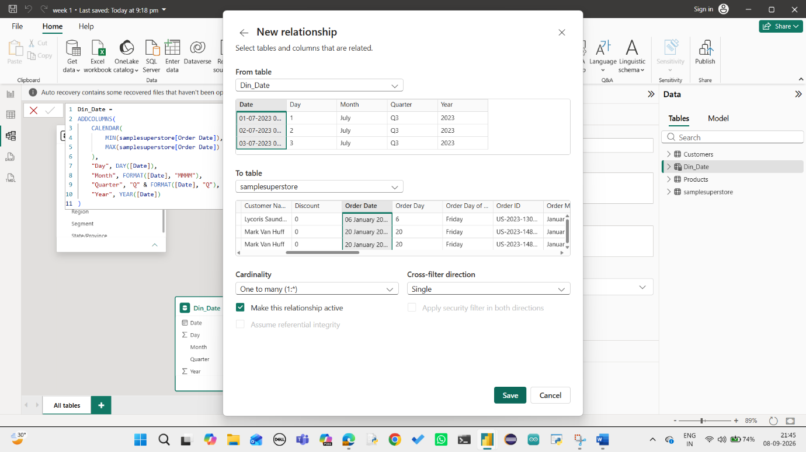
The Dim_Date table was related to the samplesuperstore table using the Order Date field. A one-to-many relationship with single-direction filtering was used for time-based analysis.
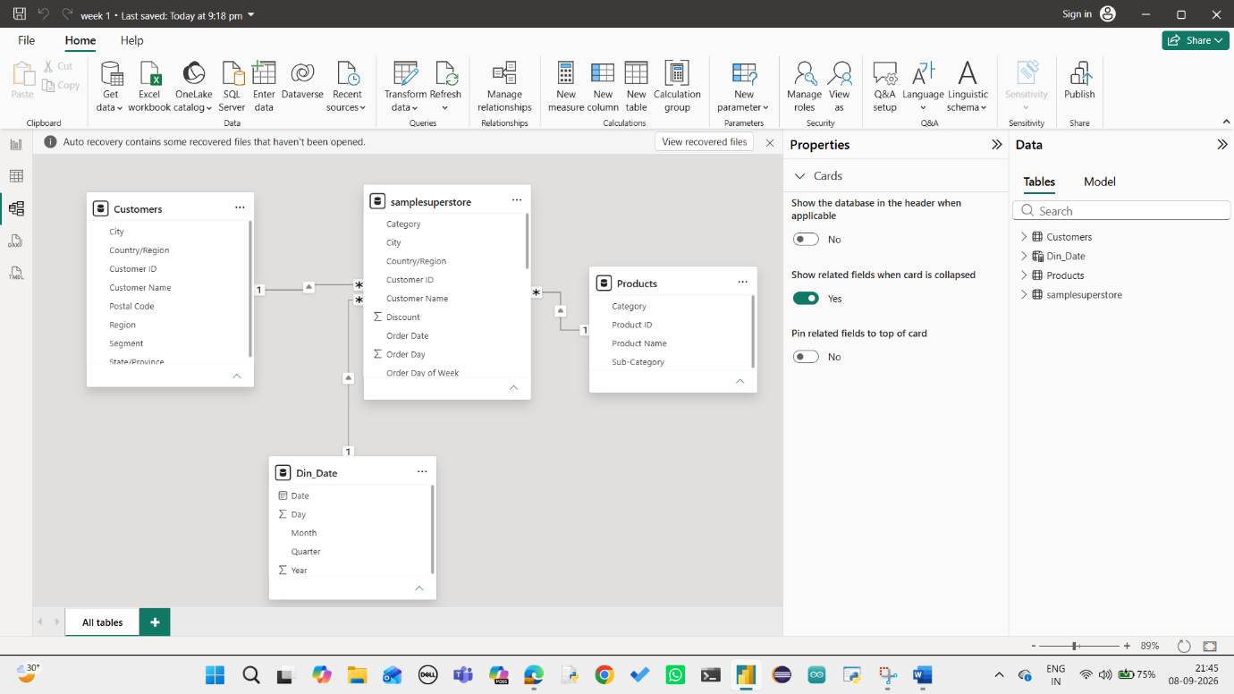
The completed data model contains the fact table and supporting dimension tables. The relationships provide a structured foundation for creating interactive visuals and DAX-based analysis.

  - 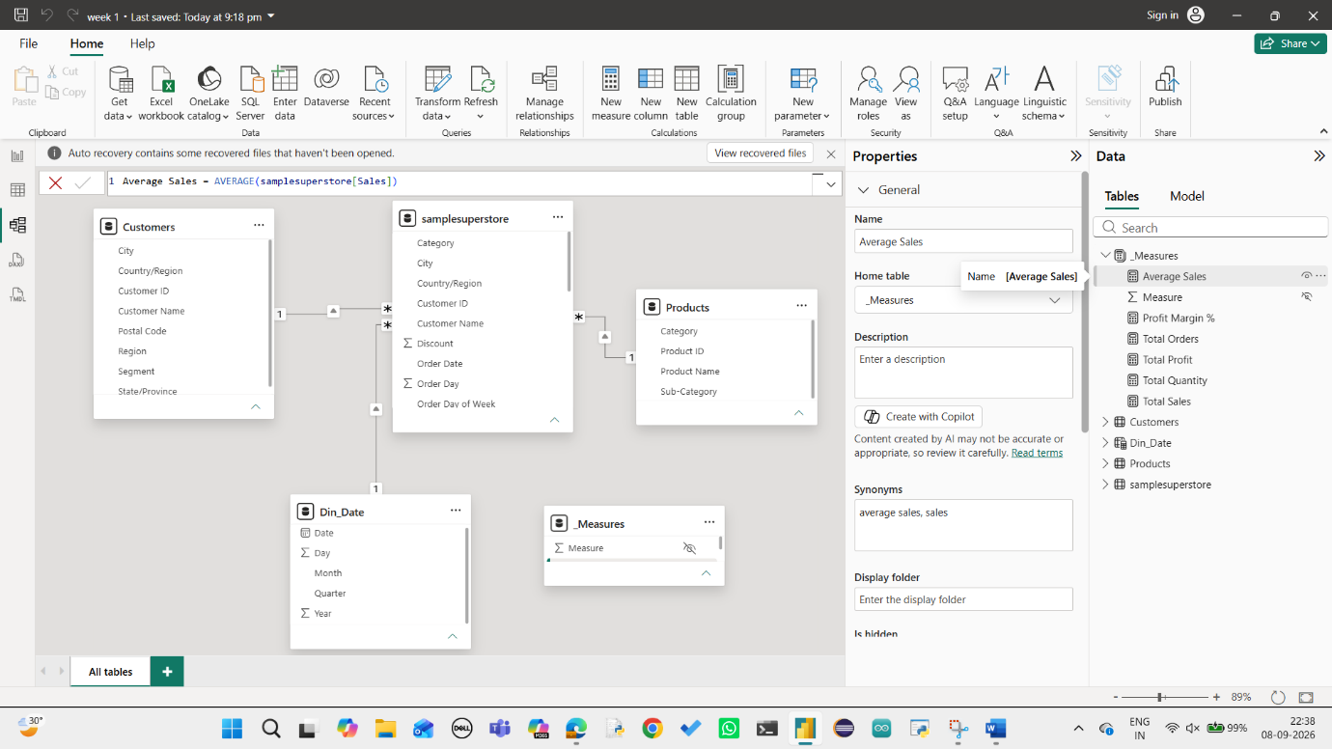
The Average Sales measure was created using the AVERAGE DAX function. It calculates the average sales value across the transactions in the Superstore dataset.
Average Sales = AVERAGE(samplesuperstore[Sales])
  - 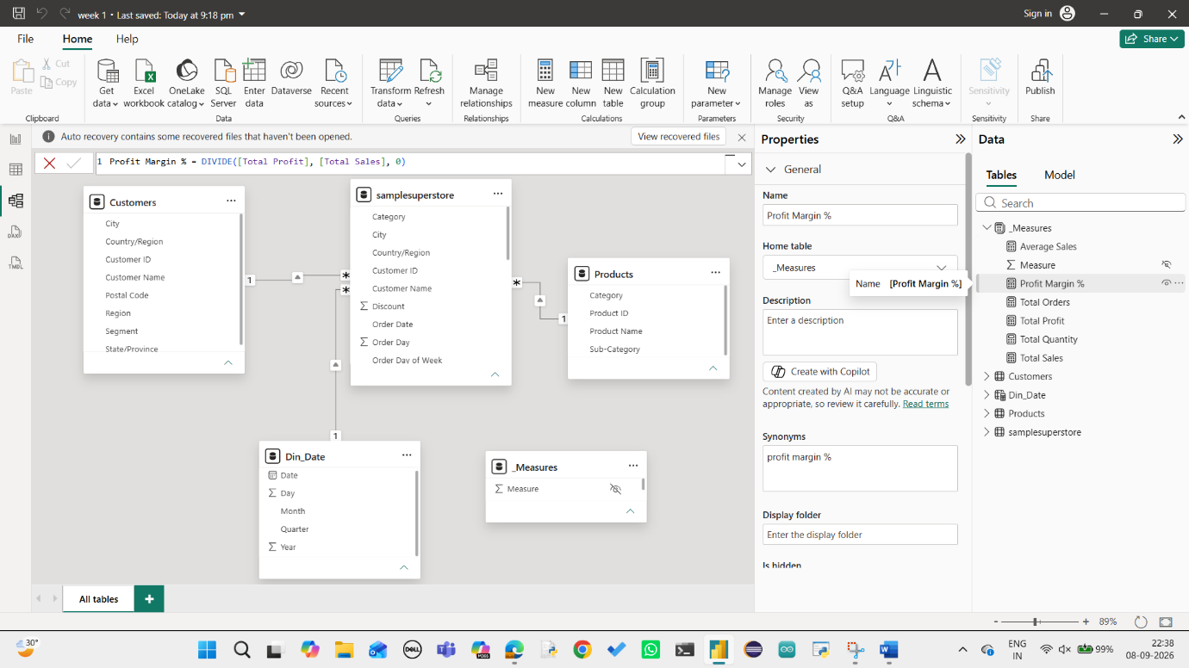
The Profit Margin % measure was created to determine the proportion of profit generated from total sales. The DIVIDE function is used to safely calculate profit margin.
Profit Margin % = DIVIDE([Total Profit], [Total Sales], 0)

  - 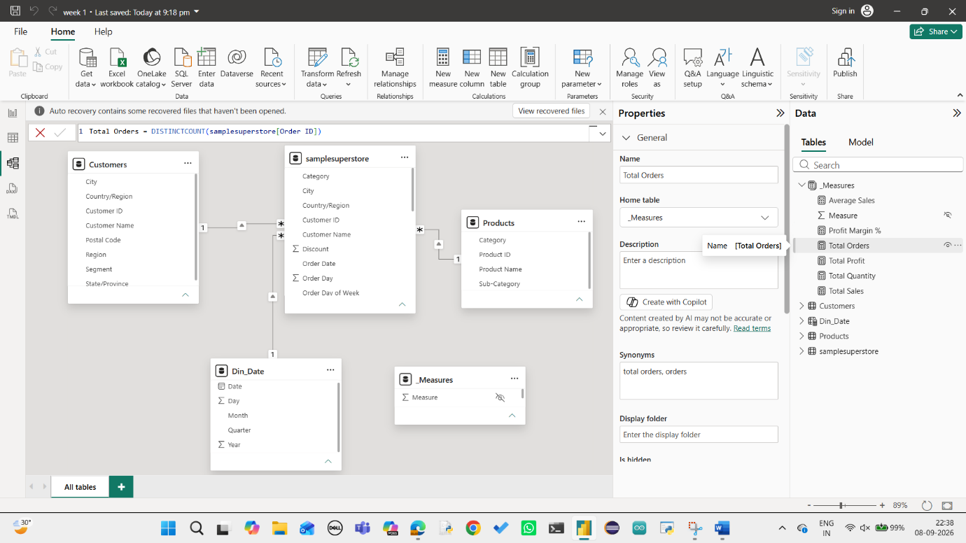
The Total Orders measure calculates the number of unique orders in the dataset. DISTINCTCOUNT is used on the Order ID column to avoid counting repeated order records.
Total Orders = DISTINCTCOUNT(samplesuperstore[Order ID])
  - 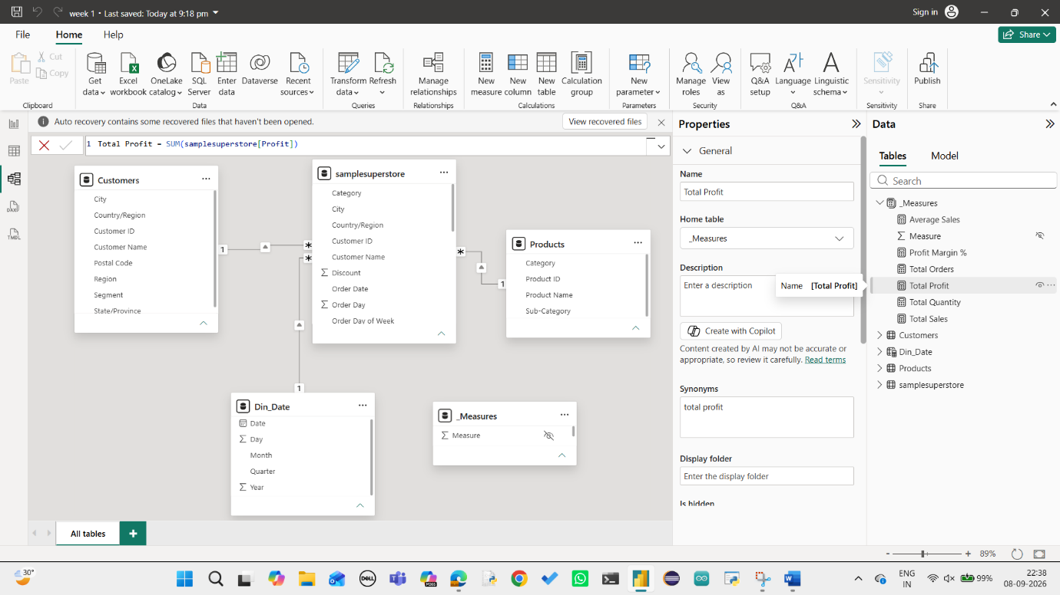
The Total Profit measure calculates the overall profit generated from all sales transactions using the SUM function.
Total Profit = SUM(samplesuperstore[Profit])

  - 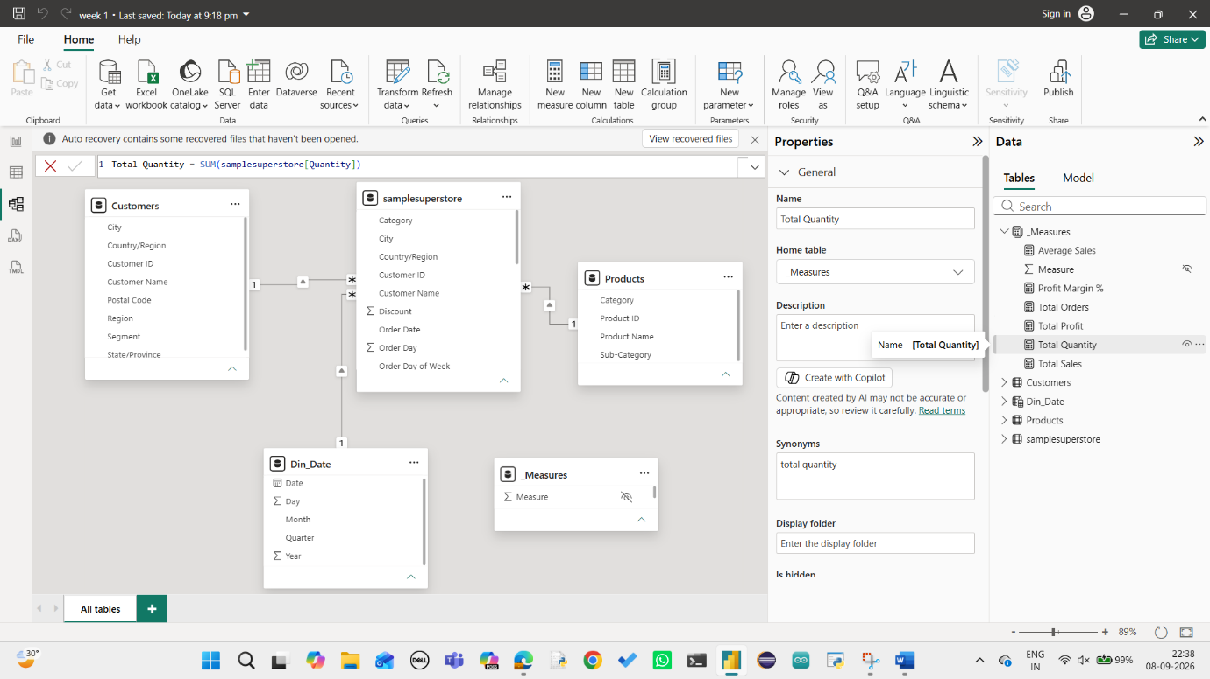
The Total Quantity measure calculates the total number of products sold across all transactions.
Total Quantity = SUM(samplesuperstore[Quantity])
  - 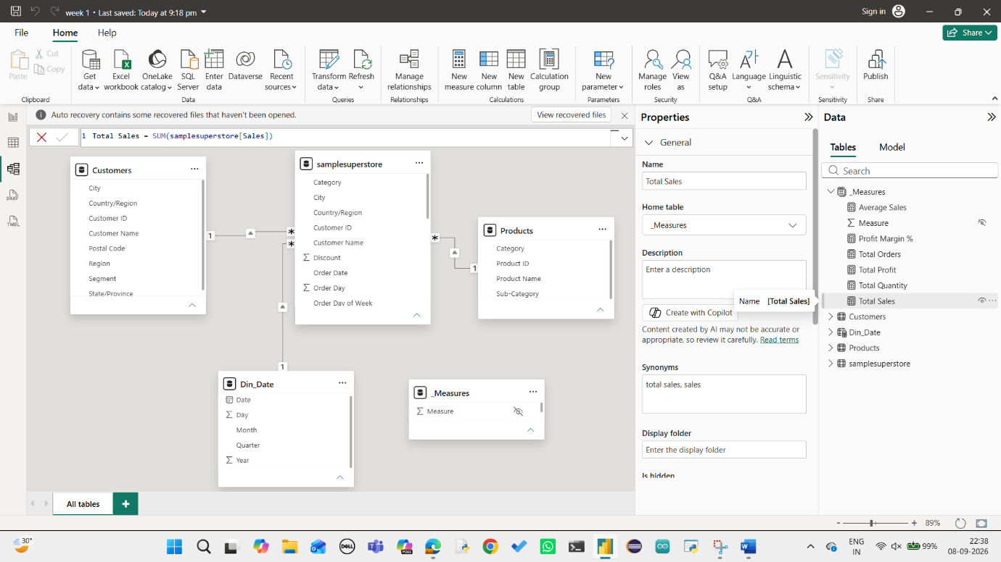
The Total Sales measure calculates the overall sales value from the Superstore dataset. This measure is used throughout the dashboard for KPI cards and visual analysis.
Total Sales = SUM(samplesuperstore[Sales])

  - 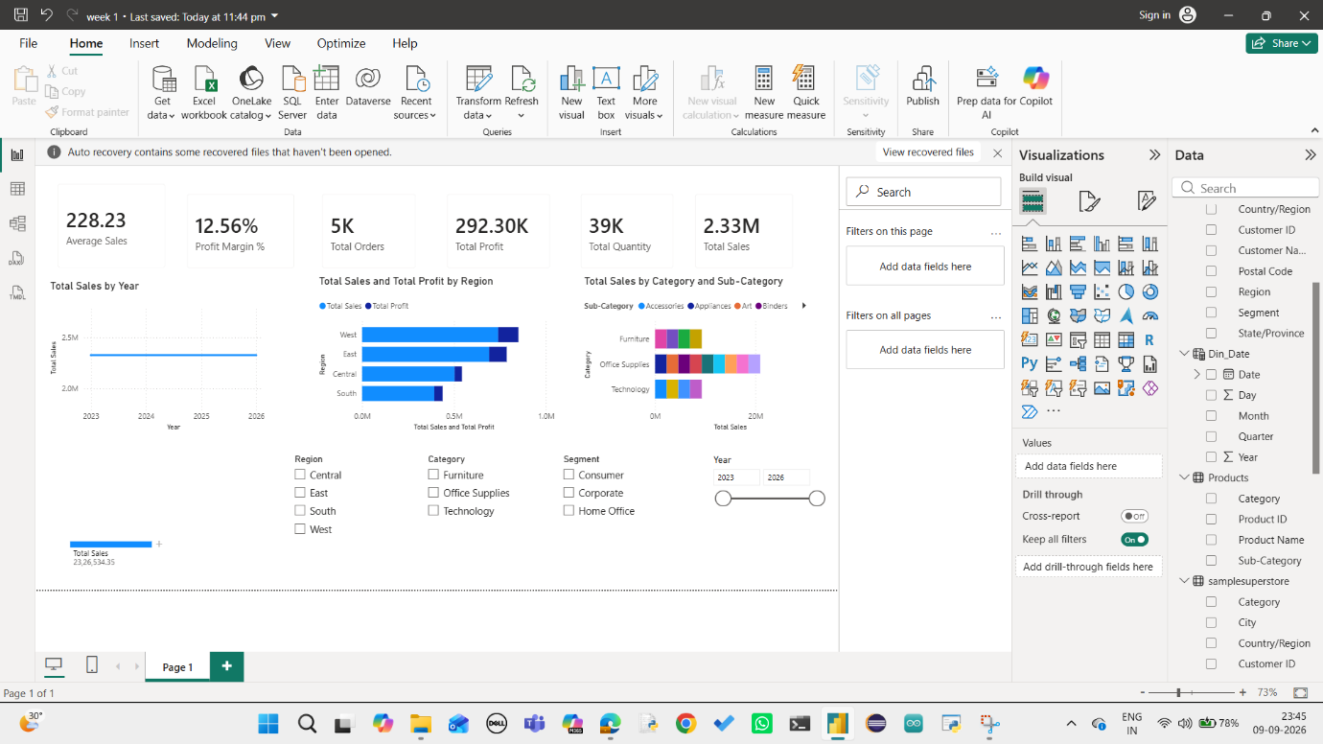
The final dashboard provides an interactive overview of Superstore sales performance. KPI cards display key metrics such as Average Sales, Profit Margin, Total Orders, Total Profit and Total Quantity, while charts provide insights into sales trends, regional performance and category-level performance. Slicers allow users to filter the dashboard by Year, Region, Category and Segment.

